# Lab 2 – Identify the Problem and Obtain Approval

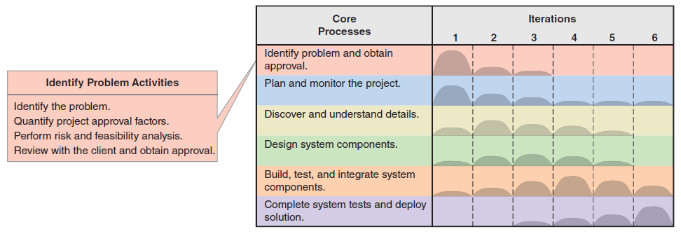

Complete the following tasks:

1. Identify the Problem
   1. Using the case study from Workshop 1, in no more than one paragraph describe what you think the problem is and the purpose of the proposed information system.

Points to highlight in your paragraph:

* Introduce the business area.
* What is the problem with the existing process?
* Why is this a problem for the organisation?
* What is the proposed information system for?
* How is the proposed information system going to address the identified problem for the organisation?

Despite establishing physical stores in major city retail centres and developing an online commercial presence, Stratosphere Pharmacies, a nationwide chain of pharmacies in Australia, faces delivery efficiency and customer experience challenges. The current delivery system may be unable to handle orders quickly and effectively in remote or hard-to-reach areas, limiting the service range and potentially affecting customer satisfaction. Additionally, the inability to track orders in real-time reduces service transparency and customer trust. With the increasing competition in the e-commerce market, traditional delivery methods must also improve cost and efficiency. Stratosphere Pharmacies has proposed introducing a drone-based pharmaceutical delivery system to address these issues. This system is expected to enhance operational efficiency by increasing delivery speed and expanding service coverage while improving customer satisfaction through real-time tracking and enhanced customer interaction, ultimately reducing operational costs while maintaining market competitiveness.

* 1. Using the case study from Workshop 1, make a list of *system capabilities* for the proposed information system. Use non-technical jargon to state each specific capability/required functionality. Use a series of bullet points. Restrict to one brief sentence per system capability.
* automated Order Processing: The system can automatically receive and process customers' online pharmaceutical and prescription orders.
* Inventory Check: For regular pharmacy orders, the system can automatically verify whether the product is part of the deliverable stock.
* Prescription Verification: For doctor's prescription orders, the system can automatically check for authenticity and government compliance.
* Drone Dispatching: The system can automatically allocate drones for the delivery of pharmaceuticals.
* Customer Identity and Location Verification: During the delivery process, the system can verify the customer's identity and location through a geolocation application.
* Real-Time Delivery Tracking: Customers can track the status and location of their order and the drone through the system.
* Transaction Record Access: Customers can access their transaction logs and view doctor information through the system.
* Customer Feedback Collection: The system provides a feature that allows customers to leave feedback about their experience.
  1. Using the case study from Workshop 1, list the *expected business benefits* that the company might derive from developing this system.

Consider the following types of benefits:

* *Tangible benefits* – Benefits that can be quantified in monetary terms. Usually stated in terms of increasing profit/revenue or minimising costs.
* *Intangible* *benefits* – Benefits that accrue to the organisation that are desirable but difficult to quantify, e.g., increased customer satisfaction, staying in business, improved reputation.

**Tangible Benefits**

* increased Revenue: Attracting more customers through fast delivery services increases the number of online orders, increasing overall sales revenue.
* Reduce logistics costs: Drone delivery may be more economical than traditional delivery methods, helping companies save on transportation costs.
* Increase operational efficiency: Automated order processing and delivery processes reduce manual intervention and improve overall business operational efficiency.

**Intangibles Benefits**

* Enhance customer satisfaction: Fast and reliable delivery service enhances customers' shopping experience, increasing customer satisfaction and loyalty.
* Strengthen market competitiveness: Innovative delivery methods enhance the Company's competitive edge, attracting more customers to choose Stratosphere Pharmacies.
* Enhance brand reputation: Being a pioneer in adopting advanced technology to improve the customer experience will help enhance the Company's brand image and industry reputation.
  1. Develop a **one-page** System Vision Document using your answers from the previous questions above. Ensure that you have the following sections:

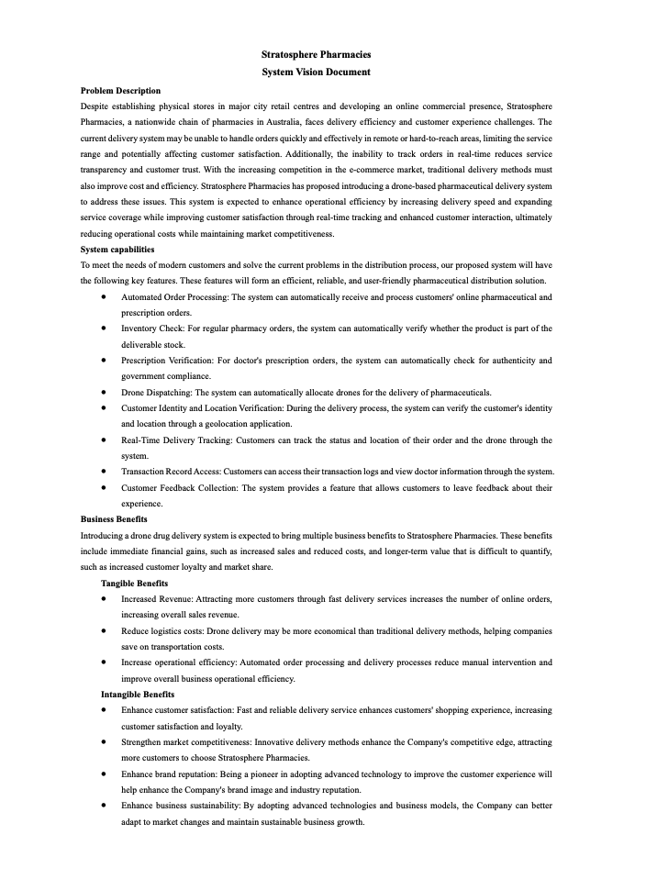

1. Quantify Project Approval Factors
   1. Propose a budget constrained to $100,000 to develop the software proposed in your System Vision Document. Use Microsoft Excel to present the budget. Ensure that you consider *at least* the following expenses:

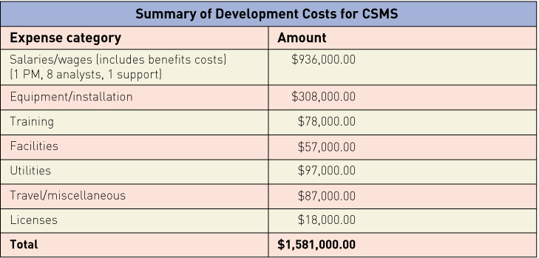

Example Information System Project Budget Categories

* 1. Use Excel’s SUM() formula to calculate the total cost.
  2. Provide a pie chart showing the breakdown of costs for the budget items.
  3. Provide references to authoritative sources justifying your cost estimates, e.g., career/recruiting websites, vendor websites and documentation.

1. Perform Risk and Feasibility Analysis

Using the case study from Question 1, undertake a Risk and Feasibility Analysis for the proposed system. Use the SWOT Analysis framework to assist you (refer to the lecture slides and textbook). Be sure to outline the following:

* 1. Organisational risks and feasibility
* **Strengths**: Stratosphere Pharmacies has an extensive chain of stores and strong brand influence across Australia, which is conducive to promoting new services.
* **Weaknesses**: The organization may lack experience in managing complex technology projects, requiring time and resources to build the necessary capabilities.
* **Opportunities**: By introducing this innovative service, the company can establish an image as a market innovator.
* **Threats**: Potential internal resistance, such as the level of employee acceptance of the new system, and challenges in change management.
  1. Technological risks and feasibility
* **Strengths**: Technological innovation, such as drone delivery, could enhance efficiency and create a new customer experience.
* **Weaknesses**: Challenges that might be faced in the implementation of technology, including system integration, data security, and privacy protection.
* **Opportunities**: Continuous technological advancements could provide possibilities for future upgrades and expansions of the system.
* **Threats**: Rapid changes in technology may quickly render current investments obsolete.
  1. Resource risks and feasibility
* **Strengths**: The company has already allocated a budget of $100,000 for this project.
* **Weaknesses**: The project might exceed its budget, particularly in the research and development and testing phases.
* **Opportunities**: Seeking external funding or government subsidies to support the development of the project.
* **Threats**: Unforeseen costs could impact the sustainability of the project
  1. Schedule risks and feasibility
* **Strengths**: The existence of a project management team may help maintain the compactness of the schedule.
* **Weaknesses**: Legal and regulatory approvals for drone delivery could cause delays in the project timeline.
* **Opportunities**: Rapid market entry can take advantage of current customer demand for fast delivery services.
* **Threats**: Potential technological development obstacles and testing delays could cause the project to be postponed.

1. Work on your assignment. Ensure that you and your assignment teammate have joined a Group (on Learning@Griffith 🡒 Course site 🡒 People 🡒 Groups tab).